Module Name: Login Page - Functional & UI Test Cases
Test Case ID: st_01
Webpage URL: https://shopeasy.ai

Scenario ID: 1a
Scenario: Sign up with valid credentials
Test Steps:
1. Open the ShopEasy website
2. Click on Login
3. Enter registered Email
4. Enter valid Password
5. Click on Login button
Screenshots:
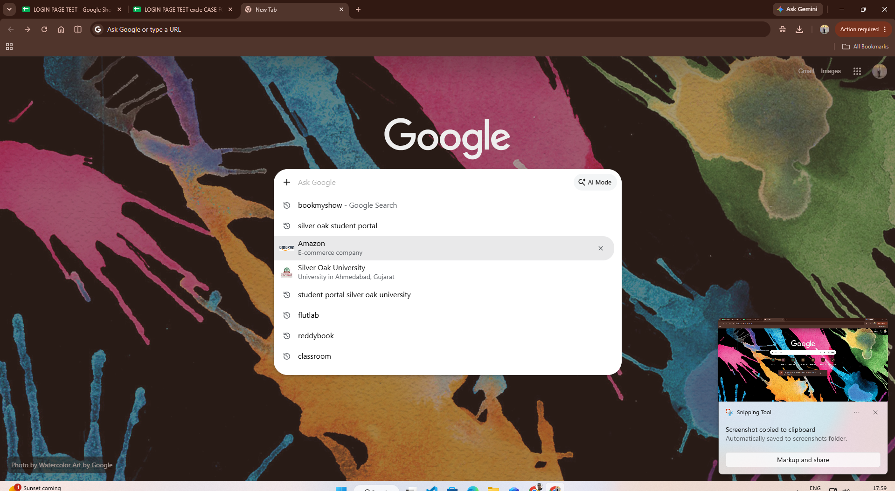

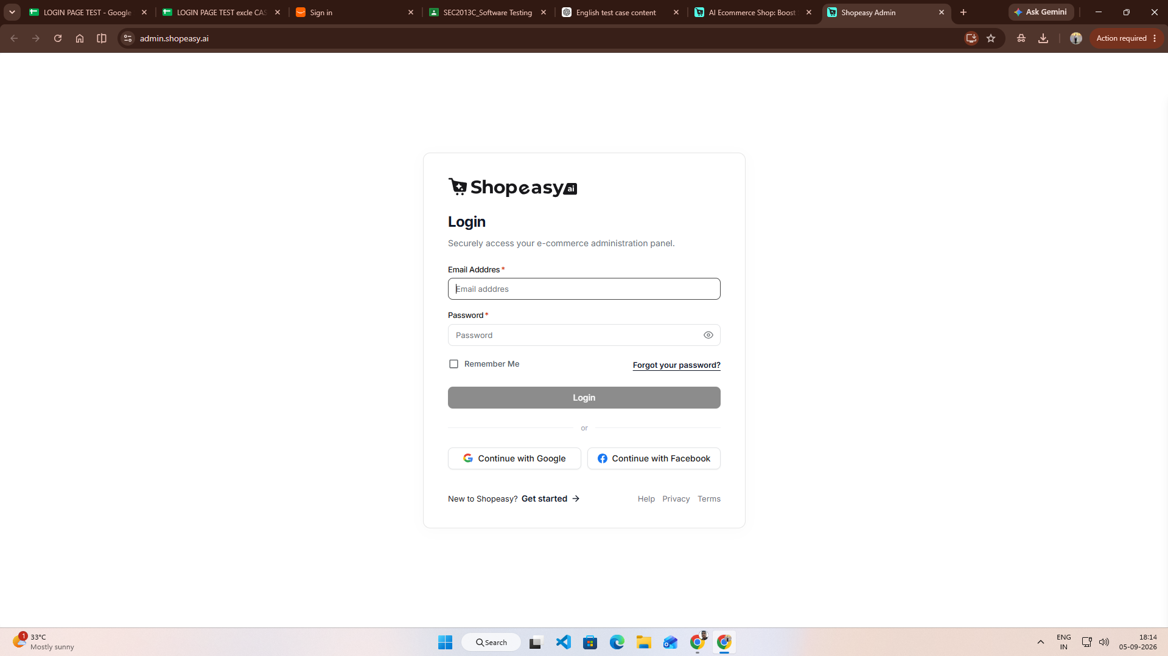
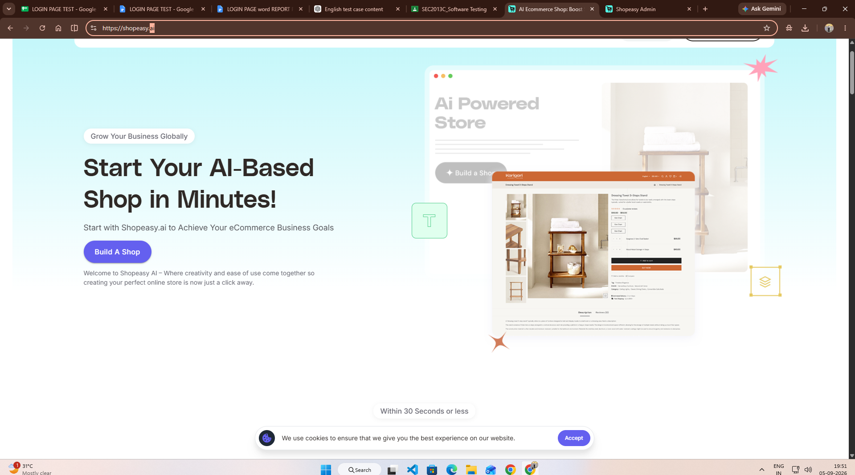

Scenario ID: 1b
Scenario: Login with invalid password.
Test Steps:

1. Enter registered Email
2. Enter valid Password
3. Click on Login button
Screenshots:
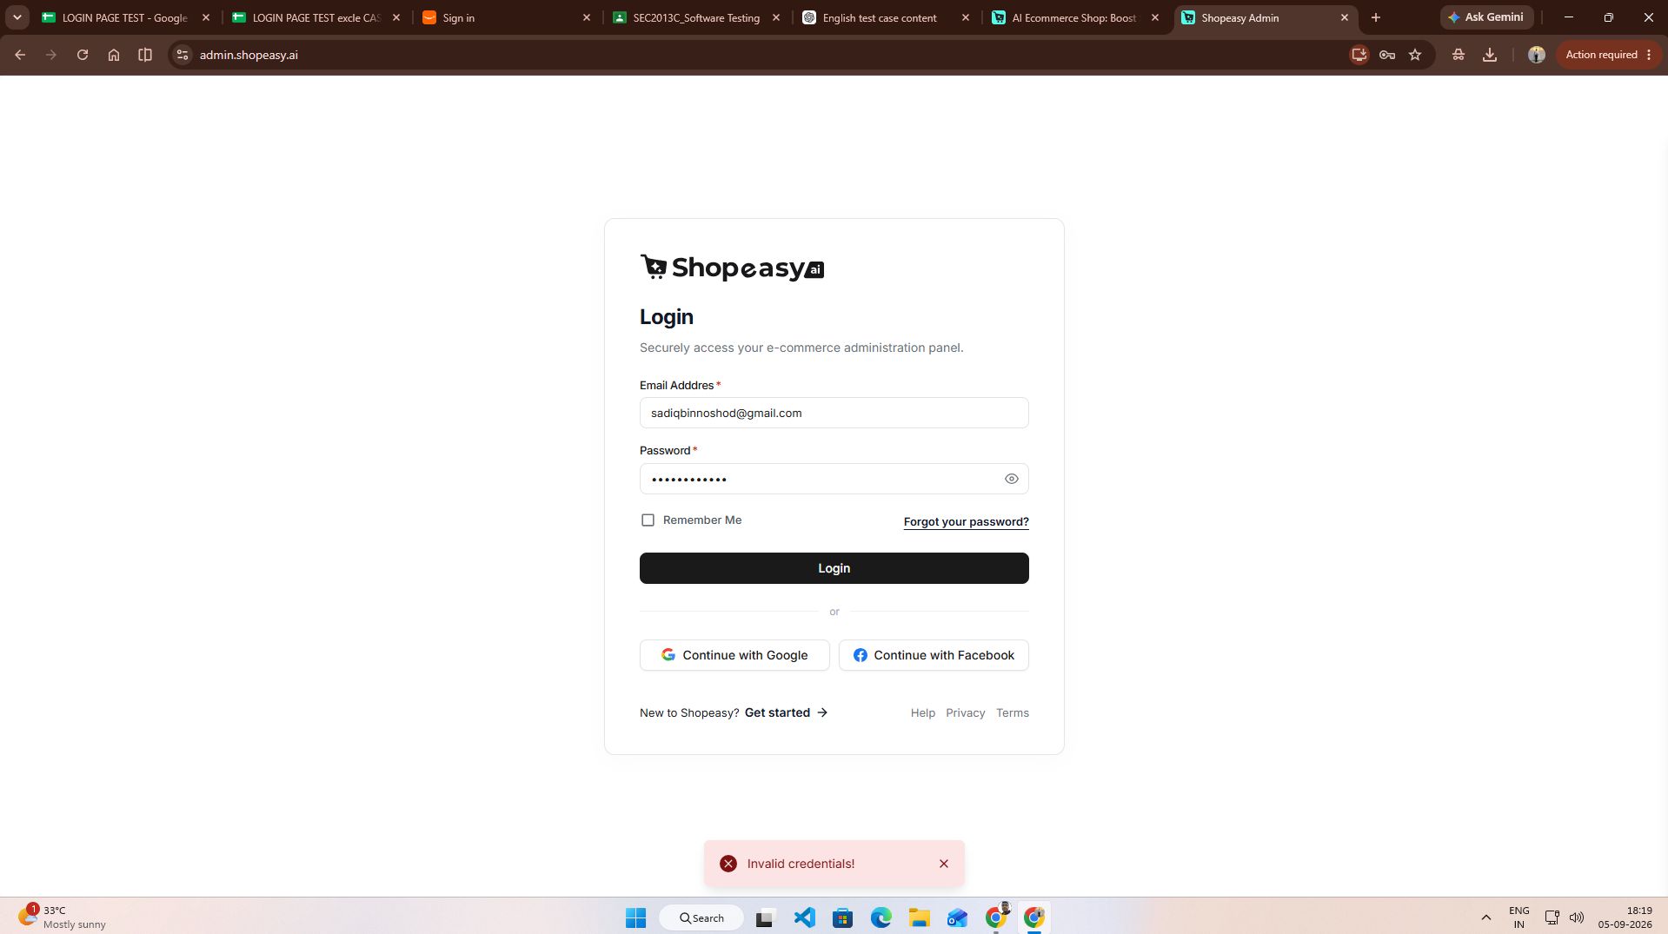

Scenario ID: 1c
Scenario: Login with unregistered email
Test Steps:
1. Open Login page
2. Enter unregistered email
3. Enter password
4. Click Login
Screenshots:
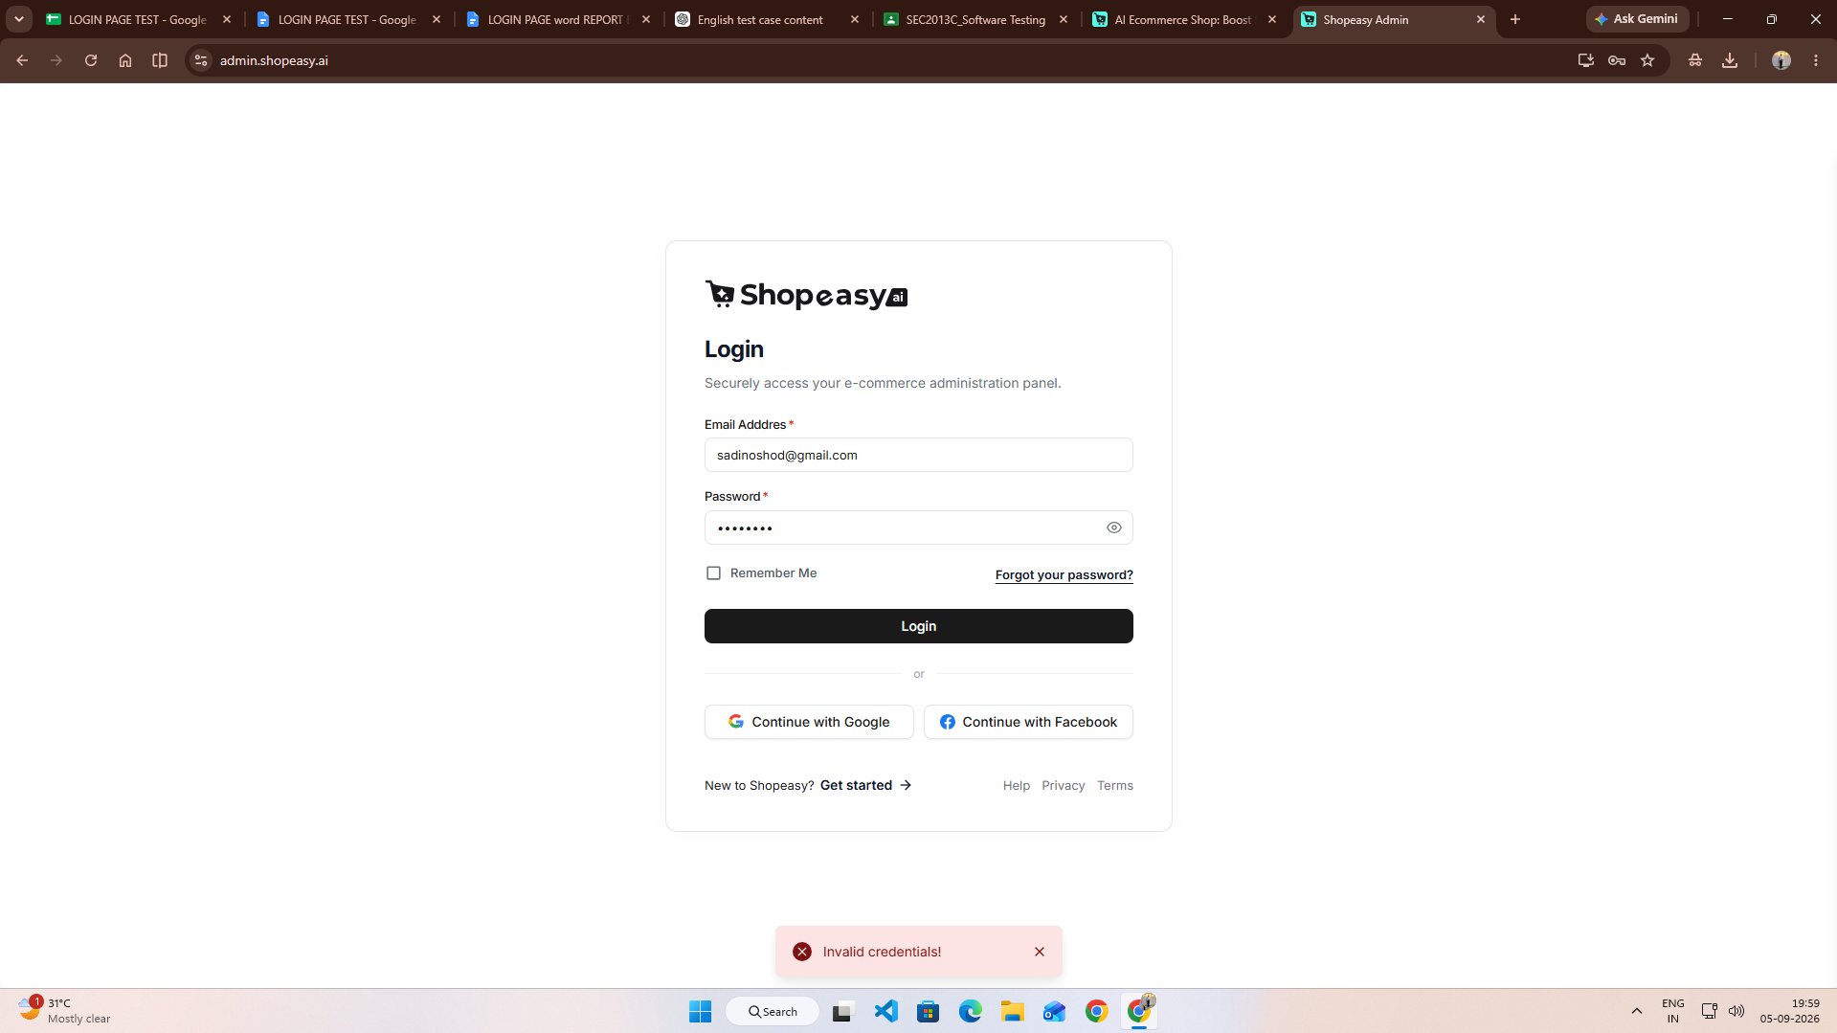

Scenario ID: 1d
Scenario: Login with empty fields
Test Steps:
1. Open Login page
2. Leave Email blank
3. Leave Password blank
4. Click Login

Screenshots:
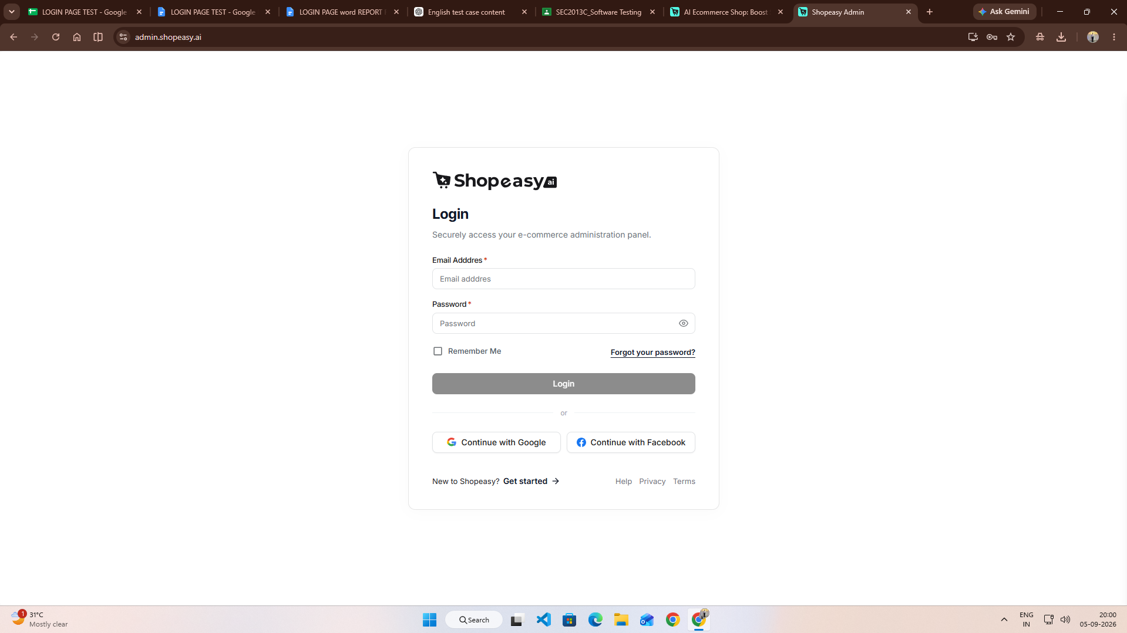

Scenario ID: 1e
Scenario: Login with invalid email format
Test Steps:
1. Open Login page
2. Enter invalid email
3. Enter password
4. Click Login
Screenshots:


